

GRAPHICS DESIGN

WITH

MICROSOFT PUBLISHER

TRAINING NOTES

TSkills® - Information Technology Solutions
Graphic Aided Design Ref: TSK/TRN/CCD

Microsoft Publisher
Microsoft Publisher 2000 helps you easily create, customize, and publish materials such as newsletters, brochures, flyers, catalogs, and Web sites. Publish easily on your desktop printer
Starting Microsoft Publisher
- Two Ways
  - Double click on the Microsoft Publisher icon on the desktop.
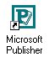
  - Click on Start --> Programs --> Microsoft Publisher.
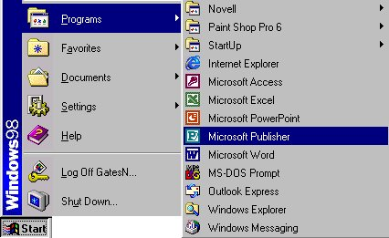

EXPLORING THE PUBLISHER SCREEN
With the Publisher Quick Publication wizard, you created a layout for your quick publication. You can now modify your publication on your own with Publisher 2000 tools, or you can return to the wizard and make any global changes to your publication - modify the Design, Color Scheme, Page Size, or Layout - without disturbing your content, or you can use Publisher's other wizards. Take a moment to explore the elements of the Publisher window.
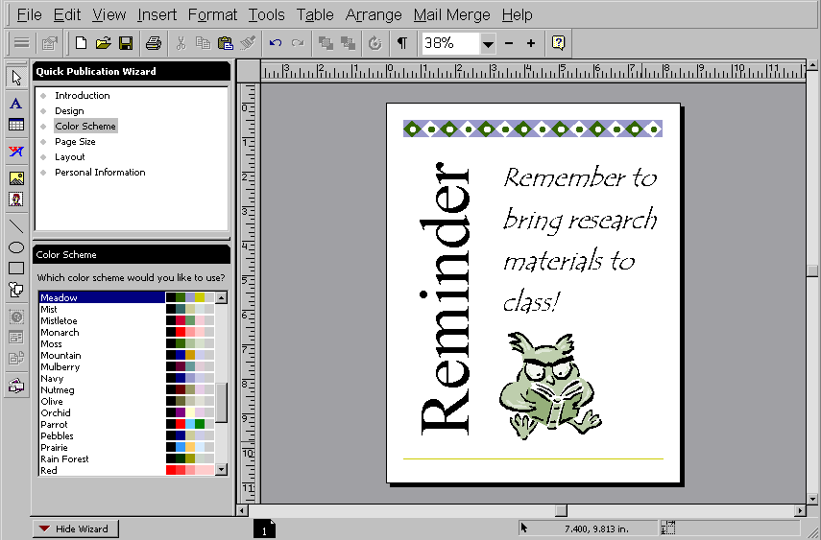  Rulers  Toolbars  Quick  Publication  Wizard  Wizard  Options  Page Icon  Hide wizard tab  Show/Hide  Wizard | Publication | Publisher main window

Depending on your publishing needs, skills, and experience, you can choose to modify your publications using the Publisher tools and toolbars. Each publication type also has a unique set of wizards. More complex publications, such as newsletters or catalogs, have more wizards than simpler publications, such as business cards and letterhead. You'll find wizards located in the left pane of the screen. They are available to you any time during the design process. ScreenTips and the Office Assistant provide additional help and are described in greater detail below.
Creating a publication using a wizard
- On the File menu, click New
- Click the Publications by Wizard tab.

- In the Wizards pane, click the type of publication you want
- In the right pane, click the design you want
- Click Start Wizard
- To make changes to the publication's color scheme, layout, or personal information now, click Next and step through the wizard's questions to make the desired changes.
- When you finish making changes, click Finish
- In your publication replace the placeholder text and pictures with your own or with other objects.
- On the File menu, click Save
- In the Save In box, select the folder where you want to save the new publication
- In the File name box, type a name for your publication
- Click Save
Using the Quick Publication Wizard with a blank publication
- On the File menu, click New
- In the Catalog, click Blank Publications
- Click the publication type you want and then click Create
- In the Quick Publication Wizard pane, click the option you want
- In the bottom pane, follow the instructions provided
- Repeat steps 4 and 5 for each option
- On the File menu, click Save
- In the Save In box, select the folder where you want to save the new publication
- In the File name box, type a name for your publication
- Click Save
Create a new publication based on a template
- On the File menu, click New
- Click Templates
- Double-click the template you want to use for your publication. (Publisher opens a copy of the template)
- Make the changes you want to create a new publication
- On the File menu, click Save
- In the Save In box, select the folder where you want to save the new publication
- In the File name box, type a name for your publication
- Click Save
Start a publication from scratch
- On the File menu, click New
- Click the Blank Publications tab
- Click the publication type you want and then click Create OR If you do not see the type of publication you want, click Custom Page at the bottom of the Catalog, and then choose the options you want
- On the File menu, click Save
- In the Save In box, select the folder where you want to save the new publication
- In the File name box, type a name for your publication
- Click Save

Open an existing publication
- On the File menu, click Open
- Click the publications you want to open, and then click Open. If you do not see the file you want, switch to the drive or folder you previously saved it in.
Create a table and type text into it
- On the Objects toolbar, click the Table Frame Tool
- Position the pointer where you want a corner of the table to appear, and then drag the mouse diagonally
- In the Create Table dialog box, choose the options you want. As you click different table formats, the Sample box displays them
- Click OK
- In the table, click where you want to add text, and then start typing. (The table automatically expands when your text fills the cell, unless you lock the table)
- Move to the next cell you want to type in

Pack your publication to take to another computer
- On the File menu, point to Pack and Go, and then click Take to Another Computer. The Pack and Go Wizard takes you through each step of the packing process. Click Next to move to the next step.
If you haven't saved your publication already, the wizard will ask you to save it
- If you're taking your publication on disk to another computer, when the wizard asks you to choose a location for saving your file, click A: OR If you're putting your files on an external drive, on a network, or on your computer's hard disk, click Browse, choose the drive and folder you want, and then click OK
- Click Next
- To embed TrueType fonts and to create links for embedded graphics, click the options you want and add a check mark. OR To not include linked graphics, click to remove the check mark.
- Click Next
- Click Finish
- In Publisher cannot find a linked graphic while packing your publication do one of the following:
  - Click Retry after you insert the disk or CD-ROM containing the original graphic into the appropriate drive.
  - Click Skip to leave the current link and replace the graphic later
  - Click Browse to locate a graphic that has been moved or to select another graphic and link it.
- Insert another disk if Publisher prompts you, and click OK. Remember the ordering of your disks for when you unpack them
- Click OK
- Unpack.exe is the program you use to unpack your files, which will be on the first disk.
Set up a publication for black and white commercial printing
- On the Tools menu, point to Commercial Printing Tools, and then click Color Printing.
  - Black and White Printing
    - In the Print all colors as box, click Spot color(s), and then click Change Spot Color.
    - In the Choose Spot Color dialog box, click Black and white only.
    - Click OK twice
  - Process-color printing
    - In the Print all colors as box, click Process colors (CMYK).
    - Click OK
  - Spot-color printing
    - In the Print all colors as box, click Spot color(s), and then click Change Spot Color.
    - In the Choose Spot Color dialog box, click the arrow next to Spot color 1, and then choose the color you want.
    - To choose a color that is not currently used in the publication, click More Colors, choose the color you want, and then click OK
    - To choose a second spot color, click the check box to the left of Spot color 2, and then click the arrow to the right and click the second spot color
    - Click OK twice.

To design a Quick Publication reminder
- If the Catalog is not already visible, click New on the File menu.
  - Click the Publications by Wizard tab.
  - In the Wizards pane, click Quick Publication.
  - In the right pane, click Accessory Bar Quick Publications.
  - Click Start Wizard. The left pane shows the wizard instructions.
  - Read the introduction and click Next.
  - Select Meadow as your color scheme and click Next.
  - Select Portrait (this is the default) and click Next.
  - Select Sidebar heading, picture at bottom from the layout choices and click Next, and then click Finish.

Toolbars and Personalized Menus
The Menu bar contains a list of menus that will help you create, edit, and format publications. As you click on each menu, additional options appear. Each option can show more choices, depending on what you are doing in Publisher 2000. If a menu option looks faded (is grayed out), the option is not currently available to you, but it will be available for other activities. If you see a chevron at the bottom of the menu, it indicates a personalized menu. Hover for a moment and more options will appear.

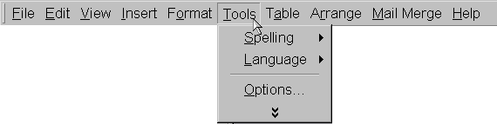
Explore the Menu toolbar by clicking on each of the
menus. For example, click Tools to see the options
in the Tools menu.

The arrows show you there are additional options for this menu item.

The chevron means more options are available.

The Standard toolbar contains buttons that give you quick access to Publisher 2000's most commonly used functions, such as opening, saving, and printing.

 | Press to open, save, and print a publication. |  |  | Undo or redo any action. |  |  | Show or hide markers. |  |  |  | Show the Office Assistant.
 |  | Cut, copy, and paste objects or text. |  |  | Move objects to back or front or rotate. |  |  |  | Zoom in, out, or choose a magnification.

The Formatting toolbars contains buttons that change according to what the type of frame you have selected (text frames for text editing, picture frames for picture editing). Each button acts on the text or object you select.
Drop-down lists used to Buttons used to underline,
format font type and size.italicize, or bold text.

FormatFormat numbering,Increase or
paragraphbullets, anddecrease the
justification.indentation.font size.

Format textChoose fill andView Rotate
wrappingline color and lineframe objects.
around graphics.formatting style.properties.

Link text frames and flow text from one frame to the next.

The Measurements toolbar contains buttons that give you the ability to do more precise higher-end work.
These fields show position, size, and angle of rotation of graphics and allow you to make precise adjustments. |  | These fields show position and size of text and line spacing and allow you to make precise adjustments.
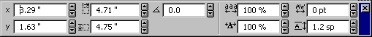

The Objects toolbar is located on the left side of the screen and can also float on the screen. You can also place it with other toolbars. The Objects toolbar contains buttons that help you create frames, place objects, and format for the web.
Selects the Pointer Tool. |  |  | Creates a WordArt frame. |  |  | Buttons used to create custom lines and shapes. |  |  |  | Use to select objects from the Design Gallery.
Used to create Text and Table Frames. |  |  |  | Used to create Picture frames and insert items from the Clip Gallery. |  |  |  | Used to work on Web sites for greater flexibility.

Zooming to change the view
Viewing text and graphics is easy when you increase and decrease the magnification of the image on screen with Zoom mode. Located on the Standard toolbar, Zoom shows the current magnification of your page. The percentages for increasing and decreasing the size of the image are preset. This does not change the actual size of the image. There are four ways to change the view:
- On the Standard Toolbar, click the Zoom drop-down box next to the plus and minus signs and then choose a new view.

Press F9 to zoom in to 100%, then press F9 again to zoom out.

- Click the plus sign (+) on the Standard Toolbar to increase the magnification (view size) of the newsletter up to 400%.
-Or-
Click the minus sign (–) on the Standard Toolbar to decrease the view size to as small as 10%.
- On the View menu, click Zoom and select a new view.
- Right-click the publication and then click Whole Page, Page Width, Actual Size, or Selected Objects.
- Click an object in your publication. Press F9 to zoom to 100%.

Work with frames
Word-processing programs, such as Microsoft Word, allow users limited control over page layout. In Publisher 2000, you have much greater flexibility because all objects on a page are contained in frames.
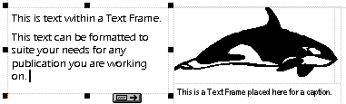
You can add multiple frames for different types of information or objects, such as text, pictures, tables, or WordArt. You can also resize or move frames to create the desired layout for your publication.
Text Frame

Selection
Handles

Frame boundaries

Icon showing Picture Frame
text flowing Caption Text Frame
to the next Picture from the
text frame Clip Gallery

To explore the frames
- Look at the Quick Publication you created. The Quick Publication contains several different frames and objects. Dotted lines show the boundaries of frames and page margins.
Note:
If you click outside the frame, it is no longer active.

- Click each frame and object of the Quick Publication. When you click a frame or object, options for working with that object appear below the Standard toolbar. Selection handles appear around objects.
- Right-click each frame of the Quick Publication. A list of commands for working with the frame appears.
- Click anywhere on the frame that contains the picture.
- Press the plus sign (+) on the toolbar to zoom in on the frame.
- Move the mouse over the center of the object. The pointer changes to an image of a moving van. When you see the moving van, you can move the object.
- Hold down the left mouse button and drag the object. Experiment with moving the frame around on the page.
- On the Edit menu, click Undo Move. This will move the picture back to its previous location. You can use the Undo command to undo up to 20 of your most recent actions.
- Hold the mouse over one of the handles until the cursor changes to a Resizer.
- Hold down the left mouse button and drag the handle to change the object.
- On the Edit menu, click Undo Resize.

Changing text and graphics in a publication
Each Publication has frames for text, pictures, and graphic elements. The Quick Publication you created has four fields. The frame at the top of the screen contains graphic elements, the frame in the center of the screen contains a picture or clip art, and the frame at the bottom of the screen contains text. You can change the content of each of these frames to fit the needs of your publication.

To change the text
- Click anywhere in the text frame. The entire text will be highlighted.
- Click the plus sign (+) on the toolbar to zoom in on the text frame.
- In the text frame, type Remember to bring research materials to class!
- Click the minus sign (-) on the toolbar or press F9 to zoom out and see the whole page.
- Click anywhere in the Title frame.
- In the title frame, type Reminder. Notice that the text automatically shrinks to fit inside the text box.

To change the graphic or clip art
- Double-click anywhere on the picture frame. The new Microsoft Clip Gallery opens.
- Click the Search for clips field, type book, and then press Enter.
- Click the owl reading a book graphic and then click the Insert clip icon or drag the new graphic on top of the current graphic in the publication. This replaces the original graphic. If you don't see that graphic, choose another one.
- Close the Microsoft Clip Gallery.

Customizing font size, text, and graphics
In Publisher, you can change the look of your text by assigning a new size or by changing the font or character spacing. When you want to put a heading in a particular spot for a flyer or newsletter, you can use AutoFit Text to fit the text in the frame.

To format font size
Publisher allows you to efficiently edit your publications. Whether you use the keyboard, shortcut keys, toolbar buttons, or built-in features like the Text in Overflow indicator, you can quickly and easily modify your publications.
- Select the sentence you typed in the text frame.
- On the Formatting toolbar, click the arrow next to Font Size, and then click 36.
You can experiment with different font sizes to see which size you prefer.
- Right-click the selected text, point to Change Text, point to Autofit Text, and then click Best Fit. The text you typed will automatically grow or shrink to fit the frame.

To format text
You can format text to fit the tone of your publication by choosing a new font. Some fonts are more formal, while other fonts have a casual tone.
- Select the text in the text frame.
- On the Formatting toolbar, click the arrow next to the Font drop-down box and then click Tempus Sans ITC. This is a simple, casual font. For a whimsical look, try the Curlz font, or for something more formal, try the Century Schoolbook font.

To change Clip Art colors
- Right-click the clip art that you inserted in the Quick Publication earlier.
- Click Change Picture and then click Recolor Picture.
- In the Color box, click the dark green square.
- Select the Leave black parts black option.
- Click OK.

To use wizards to make changes
Many of the graphic elements used in the templates have wizards associated with them so you can modify the graphics and create a publication all your own. Wizards help you customize your work to fit your purpose and style.
- Click the accessory bar at the top of the page. When you click the object, a wizard icon appears.
- Click the wizard icon. A list of graphic elements appears.
- Click each of the choices to see how the publication changes.
- Click Spotlights.
- To close the wizard, click the X in the upper-right corner.

Making additional changes to your publication
With Publisher, once you have used the step-by-step wizard to create your publication, you can go back to the wizard at any time to make global revisions like changing the design, choosing a new color scheme, or changing the layout from portrait to landscape.
In the lower-left corner of the Publisher window, you can see a Hide Wizard button or a Show Wizard button. If you prefer to use more of the screen to view your publication, click the Hide Wizard button to hide the wizard window. If you have hidden the wizard window, then click the Show Wizard button to make the wizard available. When shown, the wizards are available in the left pane of the Publisher screen.

To change your publication’s design
- If the wizard is not visible, click the Show Wizard button on the Status bar.
- In the wizard pane, click Design.
- Under Design, click Argyle. Notice the new layout applied to your Quick Publication. Try experimenting with different layouts to find one that appeals to you.
- To return to the Accessory Bar layout, click Accessory Bar on the layout list.

Change the color scheme
- Using the Quick Publication that you created, in the wizard pane click Color Scheme. The 60 available color schemes appear in the lower pane.
- Click the color scheme you prefer. When you click the color scheme, the colors on the publication change to the new scheme. You can leave the new scheme or continue to try new color schemes until you find the one that suits you. You can also create and save your own color schemes by choosing Color Schemes on the Format menu.

Saving your work, printing, and closing your publication
When you saved the file for the first time, you should have named the file. After you’ve revised a publication, you’ll want to save it again to retain the changes you have made.

To save your publication
To make sure that your changes are saved, always follow proper procedures for closing your publication.
- On the File menu, click Save. If you previously saved your publication, you have now saved the additional changes you made to the publication and you are finished saving.
If you have not previously saved, continue to step 2.
Click the Save button on the Standard toolbar to save your publication even more quickly.

- In the File Name box, type a name for your publication.
- If necessary, switch to the drive and folder you want to save the file in.
- Click Save to save the file.

To print your publication
Click the Print button on the Standard toolbar to print your publication even more quickly.

- On the File menu, click Print.
- In the Print dialog box, choose the options you want and then click OK.

To close your publication
- On the File menu, click Close.
If you have made changes since the last time you saved, click Yes to accept the changes. If you have not done anything to your document after saving it, you will exit the document and Publisher without any more options to save.

ADVANCED FEATURES IN MICROSOFT PUBLISHER

To create a calendar with the Calendar Wizard
- On the File menu, click New.
- Click the Publications by Wizard tab, click Calendars, and then click Full Page.
- In the right pane, scroll down and double-click Borders Calendar.
- Read the introduction and then click Next.
- In Color Scheme, click Clay, and then click Next.
- Click Landscape and then click Next.
- Click Monthly and then click Next.
- Click Change Dates.
- In the Start Date list, choose April and then click 1999.
- In the End Date list, choose May and then click 1999.
- Click OK, and then click Next.
- Click Yes to include a Schedule of Events and then click Finish.

Customizing your calendar
Now that you've built your calendar with the Calendar Wizard, you'll want to customize it by adding events. With Publisher 2000, you can easily return to the wizard and add items wherever you want them to appear on the calendar. The calendar is set up as a table, such as one you might find in Microsoft Word, with each day functioning as a cell.

To add dates and events to your calendar
- In the calendar’s Schedule of Events, select the word “date” in the 1st bullet and then type April 5.
- Click in the text area next to the date you just entered and type Marine Mammal Research topics due for review by Mr. Griffith.
- On the Calendar, click to the right of the date April 5th, press ENTER, and then type Topics Due.
- Continue to add events in the Schedule of Events and on the calendar dates until all of the significant events are included on the calendar.
- On the File menu, click Save to save the changes you made to your calendar.

To add art to your calendar dates
- On the Objects toolbar (vertical toolbar), click the Clip Gallery tool.
- Drag a small rectangle below the number 16 on the calendar. The Clip Gallery opens.
- In the Insert Clip Art dialog box, click the Pictures tab.
- Click the Academic category. 
- Click a picture you like and then click Insert Clip. (This icon displays first in the list that appears after you click the picture.) Or, drag the picture onto the clip art frame within your publication. The clip art appears on the calendar.
- On the File menu, click Save to save the changes you made.

To use the Newsletter Wizard
- If the Microsoft Publisher Catalog is not visible, click New on the File menu.
- Click the Publications by Wizard tab.
- In the Wizards pane, click Newsletters.
- Click Blends Newsletter and then click Start Wizard.
- Read the introduction, and then click Next.
- Select Mountain and then click Next.
- Select 2 Columns and then click Next.
- Select the No option and then click Next.
- Select the Other Address option and then click Next.
- Select the Double-Sided option and click Next.
- Select the Other Organizations option.
- Click Finish.
- Save your newsletter by clicking Save on the File menu.

Customizing your newsletter
Now that you've created the basic newsletter layout, you can drop in headlines, articles, and clip art to customize your newsletter.

To enter information on the first page of your newsletter
- Zoom in on the publication in one of the following ways:
- On the Standard toolbar at the top of the screen, click the plus sign (+) to zoom.
- Click the Zoom drop-down box next to the plus and minus signs and then select a magnification from the list.
- Press F9.
- If you created a Personal Information set in the last lesson, the Business Name should already be entered in the appropriate field. If you did not create the Personal Information set, then refer to the "Creating a Calendar" lesson in this guide to create the set.
- Click the placeholder text "Newsletter Title" and type Marine Mammals Newsletter. AutoFit is activated, so the text will get smaller as you type to fit in the text box.
- Click the placeholder text "Newsletter Date" in the upper-right corner of the newsletter and then type Spring or the month your newsletter will be published.
- Click the placeholder text "Lead Story Headline" and type Plan to Save Whales Causes Controversy or the title of your lead story.
- Click the placeholder text below the Lead Story Headline. Type your story into this frame or paste a story into the frame from Microsoft Word (or other word-processor).
- Double-click the lead story graphic. When the Clip Gallery appears, select a graphic appropriate to your story. For more information on selecting graphics, see the "Getting Your Bearings" lesson earlier in this guide.
- Click the text "Secondary Story Headline" and type Reestablishing whale pods or the title of your secondary story.
- Click the placeholder text below the Secondary Story Headline. Type your story directly into this frame, or paste a story into the frame from Microsoft Word (or other word-processor).
- In the "Inside this Issue" frame, click anywhere on the text "Inside Story" and type the title of the next article you want in the newsletter. Add as many stories as you plan to have in your newsletter.
- On the File menu, click Save to save the changes you have made to your newsletter.

To insert an existing story
- Create and save your story using your word processing software.
- In the Newsletter, click anywhere in the text frame.
- On the Insert menu, click Text File.
- Select the word processing file with the story you want to insert.
- Click Insert. The story will appear in the text frame.

To enter information in the inside of the newsletter
- To go to the second page of the newsletter, click the page icon with the number 2 on the Status Bar, which is at the bottom of the Publisher window. You should see a page icon for each of the pages currently in your newsletter.
- On the Newsletter Wizard in the left pane, click Inside Page Content. The Inside Page Content Wizard allows you to change the layout of the page to accommodate the information types you may want to add to the newsletter.
- In the lower-left pane, click the Calendar with 1 story option. The page layout now has a calendar much like the calendar you created in the previous lesson. For more information on adding information to the calendar, see the "Creating a Calendar" lesson in this guide.
- In the drop-down box in the left pane, select Right Inside Page.
- Click the Response form with 1 story option. The page now has one story and a form that can be used to accept donations for a fundraising event.
- Continue to customize headlines and articles as described earlier in this lesson.
- On the File menu, click Save to save the changes you have made to your newsletter.

Entering captions for graphics
No matter how good an illustration is, a caption can tell the readers even more. In the newsletter, each of the Picture frames also has a caption frame attached. You can also insert caption frames in your publications.

To change the caption
- Click the story graphic on the bottom of page 2.
- Press F9 to get a closer look at the caption.
- Click the caption and type a sentence describing the significance of the graphic or picture to your lead story.
- Click outside the Text Frame.
- Press F9 to zoom out to see the whole page again.

Adding or deleting extra pages
The newsletter you created may contain fewer or more pages than you'll need. Adding and deleting pages is simple. If you need six pages to fit the content in your newsletter, follow the instructions for adding extra pages. If you need only two pages to fit the content in your newsletter, follow the instructions for deleting extra pages.

To add extra pages
- On the Insert menu, click Page. The Insert Page dialog box appears.
- In the Left Page drop-down box, select the layout you want for the page.
- In the Right Page drop-down box, select the layout you want for the page.
- Click OK to add two pages.

To delete extra pages
- To go to the second and third pages of the newsletter, click the page icon with the number 2 or 3, which is at the bottom of the Publisher window.
- On the Edit menu, click Delete Page.
- Select Both pages.
- Click OK to delete the pages.

To replace a graphic with a scanned image
- Place your photo on the scanner and scan the image.
- In Publisher 2000, right-click the graphic you want to replace.
- Point to Change Picture, then point to Picture, then point to From Scanner or Camera, and then click Acquire Image. Publisher 2000 will find the scanner and import the image. To learn more about scanning graphics into Publisher 2000, ask the Office Assistant "How do I add a picture from my scanner?"

Converting your newsletter to a Web site
Publisher lets you convert any publication to HTML, so the publication can be viewed with a Web browser. If you create a Newsletter or Brochure publication in Publisher 2000, you can easily transfer its content to a Web site with a Web layout. This is useful when the information you present and promote in the newsletter is of interest to students and to your entire community.

To publish your newsletter on the Web or school Intranet
- In the newsletter you have created, click Show Wizard (unless the wizards are already visible).
Note:
To preview a Web publication, you need a Web browser. The Microsoft Internet Explorer browser is included on the Publisher 2000 CD.

- In the top Wizard pane, click Convert to Web Site.
- In the bottom Wizard pane, click Create.
- In the Convert to Web Site dialog box, click OK.
The newsletter content appears in the Web site format.
- On the File menu, click Save as Web Page. The page is saved in the folder you select.
- On the File Menu, click Web Page Preview.
- On the Web Page Preview dialog box, click OK to view your newsletter with a Web browser.
- When you're finished previewing your Web site, close your Web browser.

To use the Letterhead Wizard
- On the File Menu, click New.
- Click the Publications by Design tab.
- Under Design Sets, click Master Sets and then click Marquee.
- In the right pane, click Marquee Letterhead.
- Click Start Wizard, read the introduction and then click Next.
- Under Color Scheme, click Mist and click Next.
- Select the Logo option and then Click Next.
- Under Personal Information, click Other Organization and then click Finish.

To use a Smart Object Wizard
- Click anywhere on the stripes at the top of the letterhead. The Smart Object Wizard icon appears.
- Click the Wizard button. The Marquee Creation Wizard appears.
- Click Checkerboard to select the checkerboard design.
- Click the X in the upper-right corner of the Marquee Creation Wizard to exit the wizard.

To customize the logo on your letterhead
- Click anywhere on the logo in the lower-left corner of the letterhead. The Logo Creation Wizard appears.
- In the wizard pane, click New or Existing.
- In the bottom pane, click Publisher-Created Logo.
- In the top wizard pane, click Design.
- Under Design, click Suspended Rectangle.
- In the wizard pane, click Number of lines and click whether you want one, two, or three lines of text combined with your logo.
- In the text frame, type your school name and fundraising organization.
- Double-click the graphic frame and insert a new graphic from the Insert Clip Art window.
- On the File menu, click Save to save the changes you made.

To choose your own picture for a logo
- In the wizard pane, click New or Existing.
- In the bottom pane, click Picture File That I Already Have and then click Insert Picture.
- Locate your picture file and then click OK.
- Close the Logo Creation Wizard.
- On the File menu, click Save to save the changes you made.
- On the File menu, click Print and follow the instructions in the print dialog.

Creating coordinating envelopes
Create envelopes that match your letterhead and give your organization a more professional look. Use Publications by Design to find coordinating publication designs within one of the twenty master design sets.

To create coordinating envelopes
- On the File Menu, click New.
- Click the Publications by Design tab.
- Under Design Sets, click Marquee.
- In the right pane, click Marquee Envelope.
- Click Start Wizard.
- Read the introduction and then click Next
- Under Color Scheme, click Mist and then click Next.
- In the Size pane, click #10 and then click Next.
- Select the Yes option to include a logo and then click Next.
- Under Personal Information, click Other Organization and then click Finish.
- Modify the stripe and logo to look consistent with your letterhead.
- In the Mailing Address frame, type the mailing address of the letter recipient. If you prefer to use Mail Merge, refer to the Office Assistant or see Adding Names to your certificates with Mail Merge in the "Publicizing a School Event" lesson in this guide.
- Save the envelope.

To create a brochure with a wizard
- To display the Catalog on the screen, click New on the File menu.
- Click the Publications by Design tab.
- Under Design Sets, click Marquee and then click Marquee Informational brochure.
- Read the introduction and then click Next.
- Under Color Scheme, click Mist and then click Next.
- In the Paper Size pane, click Letter (8.5 x 11 in), 3 panels, and then click Next.
- Select the Yes option to include a placeholder for an address and then click Next.
- Under Form, click None for attached forms and click Next.
- Under Personal Information, click Other Organization.
- Click Finish.
- Save your brochure.

Modifying your brochure
Now that you've created your brochure, use Publisher 2000 to customize your brochure with text and picture frames.

To modify your brochure
- On Page 1, click the text Product/Service Information in the right panel and type Free Willy Keiko Foundation. The rest of the right-hand panel text frames have the information from your Personal Information set. If you have not yet created a Personal Information set, refer to the Office Assistant or see the "Creating a Calendar" lesson in this guide to create one.
- Click anywhere on the awning stripe and use the wizard to change the stripe to Checkerboard.
- Double-click the Picture frame and replace the current graphic with a graphic you prefer.
- In the left panel, click the Back Panel Heading text frame and replace the text with your own heading. Then, replace the text in the text frame below the heading.
- Double-click the graphic frames and insert a new graphics from the Clip Gallery.
Note:
You may need to have the Publisher CD-ROM available in order to access much of the Clip Art.

- To go to the inside pages of the brochure, click the page icon with the number 2, which is at the bottom of the Publisher window.
- Click and replace the text in the Main Inside Heading frame. Continue by replacing the text in the text frames on this page. Remember you can insert an existing test file, such as one that you've written in Microsoft Word, or type directly into the text frames. See To insert an existing story in the "Creating a Newsletter" lesson in this guide for more information.
- Double-click the graphic frames and insert a new graphics from the Clip Gallery.
- On the File menu, click Save to save the changes you made.
- On the File menu, click Print and follow the instructions in the print dialog to print your brochure.

To create a Thank You card
- On the File menu, click New.
- Click the Publications by Design tab.
- Under Design Sets, click Marquee and then click Marquee Thank You Card.
- Read the introduction and then click Next.
- Under Color Scheme, click Mist and then click Next.
- Click Finish.
- Save the Thank You card.

To customize your Thank You card
- Click anywhere on the awning stripe and use the wizard to change the stripe to Checkerboard.
- In the Greeting Card Wizard in the left pane, click Suggested Verse and then click Browse. The Suggested Verse dialog box appears.
- Click one of the available messages. The front and inside messages appear in the right fields of the Suggested Verse dialog.
- When you have found the message you want, click OK. You can also write your own message.
- To go to the inside page of the card, click the page icon with the number 2, which is at the bottom of the Publisher window. You should see a page icon for each of the pages currently in your card.
- Add text you want in the text box on page 2.
- Check the rest of the card and make any changes you want.
- Save the Thank You card.

To create an invitation
- On the File menu, click New.
- Click the Publications by Wizard tab.
- In the Wizard pane, click Invitation Cards and then click Fund-raiser invitation.
- In the right pane double-click Mobile Fund-raiser Invitation.
- Click Start Wizard.
- Read the introduction and then click Next.
- Under Color Scheme, click Waterfall and then click Next.
- Click Browse. In the Suggested Verse dialog select the Do a Good Deed message, and then click OK. Click Next.
- Click Other Organization and then click Finish.
- On the File menu, click Save.
- In the File Name box, type a name for your postcard.
- If necessary, switch to the drive and folder you want to save the invitation in.
- Click Save to save the file.

Customizing your invitation
Now that you have created your invitation, you can use the text frames to customize your invitation. Be sure to include all of the relevant information for your fundraising event, such as the time, place, and date.

To customize your invitation
- To go to the inside page of the invitation, click the page icon with the number 2, which is at the bottom of the Publisher window. You should see a page icon for each of the pages currently in your invitation.
- On page 2, click the Fund-raiser Title text frame at the top of the invitation.
- Select the text and then type Free Willy Keiko Foundation Fundraiser.
- In the upper portion of the center text frame, type a brief description of the fundraising event that explains why it is important.
- Replace "Contact Person" with the name of your contact person and replace 555-555-5555 with a contact phone number.
- In the Date and Time frames, type the date and time you have arranged for your fundraising event.
- In the lower part of the center text frame, give directions to the event location.
- The information on the back is inserted as part of the Personal Information set. If you have not yet created a Personal Information set, refer to the Office Assistant or see the "Creating a Calendar" lesson in this guide.
- On the File menu, click Save to save the changes you have made.

Creating a Catalog

A catalog is a great way to show potential customers the products and services you have to offer. Use the Catalog wizard to create an eye-catching publication that will let you show participants what they can bid on for a silent auction. Also, learn how to prepare a publication to go to a commercial printing service or to take to a copy shop for printing. (If you want to print a large quantity of catalogs in 4-color, you may find it more economical to use a commercial printing service. Check with your printer or copy shop for more information.)

To create a catalog
- On the File menu, click New.
- Click the Publications by Wizard tab.
- In the Wizard pane, click Catalogs.
- In the right pane click Arcs Catalog.
- Click Start Wizard.
- Read the introduction and then click Next.
- Under Color Scheme, click Glacier and then click Next.
- Click No for the customer's address and then click Next.
- Click Other Organization and then click Finish.
- On the File menu, click Save.
- In the File Name box, type a name for your catalog.
- If necessary, switch to the drive and folder you want to save the catalog in.
- Click Save to save the file.

To customize your catalog
- In the Date text frame, type in the date of the fundraiser.
- In the Catalog Title text frame, type in Free Willy Keiko Foundation Fundraising Event.
- In the Catalog Subtitle text frame, type in Silent Auction Items.
- In the Sidebar Heading text frame, type in the benefits of donating.
- Double-click anywhere in the Picture frame and insert a new graphic.
- To go to page 2 of the catalog, click the page icon with the number 2, which is at the bottom of the Publisher window. You should see a page icon for each of the pages currently in your catalog.
- In the Catalog Wizard pane on the left side of the screen, click Inside Page Content. A list of page layout types appears in the lower-left pane.
- Click One column, all text. You can then insert text on page 2 explaining why your organization has chosen to have the fundraising event and where the proceeds will go.To create the Table of Contents for your brochure, you may want to come back to page 3 after you have inserted the rest of the catalog content so you know which page each entry is on.
- To go to page 4 of the catalog, click the page icon with the number 4, which is found at the bottom of the Publisher window.
- In the Catalog Wizard pane on the left side of the screen, click Inside Page Content.
- Click Four items, aligned pictures.
- Click the arrow next to Left Inside Page in the lower-left pane and then click Right Inside Page.
- Click Four items, aligned pictures.
- On page 4, right-click in the first Picture frame, choose Change Picture, then choose Picture, and then choose From File.
- Find the appropriate picture file, select it and then click Insert.
- Repeat steps 14 and 15 for the remaining Picture frames on pages 4 and 5.
- In the Text frame next to each picture, insert a description of that item. In the text frame below, insert the number associated with that item.
- Repeat steps 9 through 16 for pages 6 and 7.
- Return to page 2 and insert the item names and page numbers in the Table of Contents.
- The rest of the text frames on page 8 contain the information from your Personal Information set. If you have not yet created a Personal Information set, refer to the Office Assistant or see the "Creating a Calendar" lesson.

To add extra pages
- Go to the page after which you would like to add pages.
- On the Insert menu, click Page. The Insert Page dialog box appears.
- In the left-hand page drop-down box, select a page layout. A preview of the layout appears below the drop-down box.
- In the right-hand page drop-down box, select a page layout. A preview of the layout appears below the drop-down box.
- Click OK.

To delete extra pages
- Go to the page you would like to delete.
- On the Edit menu, click Delete Page.
- Click Both pages, Right page only, or Left page only.
- Click OK.

To print your catalog
- Make sure you have saved your publication and that you have inserted a disk in your floppy disk or zip disk drive.
- On the File menu, choose Pack and Go and then click Take to a Commercial Printing Service or Take to Another Computer. The Pack and Go Wizard dialog box appears.
- Read the introduction and then click Next.
- Select the location for the packed publication (usually A:/ for a floppy disk or D:/ for a zip disk) and then click Next.
- To include fonts and graphics in the packed publication, make sure to select the correct check boxes and then click Next. Normally, you will choose the default settings.
- Read the information you have selected. If for any reason you need to change any of the selections, click Back to return to the selection and change your selection.
- To save your publication to a disk to take to a printer, click Finish.

Creating and customizing a banner
Let Publisher Banner Wizard help you create a colorful banner to publicize your fundraising activities or to decorate for dances, dinners, parties, ceremonies, and other events.

To create a banner
- On the File menu, click New.
- Click the Publication by Wizard tab, click Banners, and then click Informational.
- In the right pane, click Checked Frame Banner.
- Click Start Wizard.
- Read the introduction and then click Next.
- Click 10 feet and then click Next.
- Click 11 inches and then click Next.
- Click Both Sides and then click Next.
- Click Yes to include a border and then click Finish.
- On the File menu, click Save.
- In the File Name box, type a name for your banner.
- If necessary, switch to the drive and folder you want to save the banner in.
- Click Save to save the file.

To customize your banner
- Click the Your Text Here text frame and then type Free Willy Keiko Foundation Fund-raising Dinner.
- Double-click one of the Picture frames.
- Replace the graphic with a graphic appropriate to the banner.
- Repeat steps 2 and 3 for the other Picture frame.
- On the banner File menu, click Save to save the changes you have made to your banner.

To print your banner
- On the File menu, click Print.
- Click Tile Printing Options.
- Click Cancel.
- Make sure at least 18 sheets of paper are loaded in your printer.
- Click OK to print your banner.
- To assemble the banner, place the printed sheets end to end, overlapping the edges of each sheet 0.25 inches. Then, glue or tape the pages together to create the banner. For more information on printing your banner, ask the Office Assistant “How can I assemble a banner?"

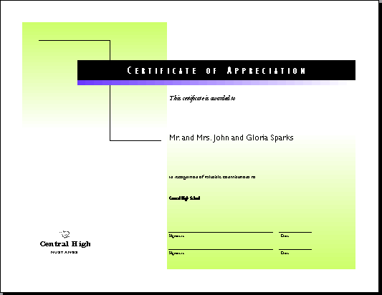
Creating a certificate
Publisher can help you create framable certificates of achievement you can display in your classroom. You can also create certificates for students and members of the community to acknowledge their contributions to your fundraising efforts.

To create a certificate
- On the File menu, click New.
- Click the Publications by Wizard tab, click Award Certificates, and then click Plain Paper.
- In the right window pane, click Certificate of Appreciation.
- Click Start Wizard.
- Read the introduction and then click Next.
- Under Color Scheme, click Iris and then click Next.
- Click Other Organization and then click Finish.
- On the File menu, click Save.
- In the File Name box, type a name for your certificate.
- If necessary, switch to the drive and folder in which you want to save the certificate.
- Click Save to save the file.

Customizing your certificate
Now that you've created the general layout for your certificate, you are ready to add your personal touch. This version of the certificate uses plain paper with shades of color for emphasis.

To customize your certificate
- Click Name of Recipient and type the name of the person who will receive the certificate. You can also merge names from your address list or existing database using the instructions below. The rest of the text frames on the certificate contain the information from your Personal Information set. If you have not yet created a Personal Information set, refer to the Office Assistant or see the "Creating a Calendar" lesson in this guide.
- On the File menu, click Save to save the changes you have made.
- On the File menu, click Print and follow the instructions in the print dialog to print your certificate.

Adding Names to your certificates with Mail Merge
You can also choose to use Mail Merge to add names to a group of certificates. Using a name list you create in Publisher (see below) or using an existing database created in Microsoft Works, Excel, or Access, you can use Mail Merge with your publication.
Some features, such as Mail Merge, were not automatically installed when you first installed Publisher 2000. If Mail Merge does not work when you try the steps below, you will need access to the Publisher 2000 CD-ROM to complete these steps.

To create a list in Publisher (optional)
- On the Mail Merge menu, click Open Data Source.
- Click Create an address list in Publisher.
- Type the name and address information in the Enter Address Information field. You can leave fields blank. You may need to scroll down the list to fill in all pertinent information.
- Click New Entry to save the name and address information as an entry. Empty fields appear for the next entry.
- Continue to add address information and save it by clicking New Entry.
- When you have added all the names and addresses for your project, click Close. The Save As dialog box appears.
- In the File Name field, type a name for your list.
- If necessary, switch to the drive and folder in which you want to save the address list.
- Click Save to save the file and create the list. A dialog appears asking if you want to merge the information from this list now.
- If you want to continue, click Yes. The Insert Fields dialog box appears.

To add addresses to your publication
- Go to page 1 of your publication.
- In the Name of Recipient text box, click to the left of the "D" in the word "Do."
- If you are using the list you just created, go to the next step.
-Or-
If you are using a list from another data source, on the Mail Merge menu, click Open Data Source and select a source from the options.
- In the Insert Fields dialog box, click the First Name field.
- Click Insert. Publisher inserts placeholder text ("Name") called a field code into the selected text frame.
- Click Close.
- Type a comma and press ENTER. You would repeat the above steps if you were merging additional fields, such as for an address label or envelope. You can move, copy, or format the field codes just as you would regular text. If you need to change a field code, you must edit it within the data source or Publisher address list.
- On the Mail Merge menu, click Merge. Field codes are replaced by information from the first entry of your data source. In the Preview Data dialog box, use the navigation buttons or type in an entry number to see what other entries look like in your publication.
Your publication is ready to print.
- On the File menu, click Save to save the changes you made.
- On the File menu, click Print Merge and follow the instructions in the print dialog to print your publication.

Building a Web site with the Web Site Wizard
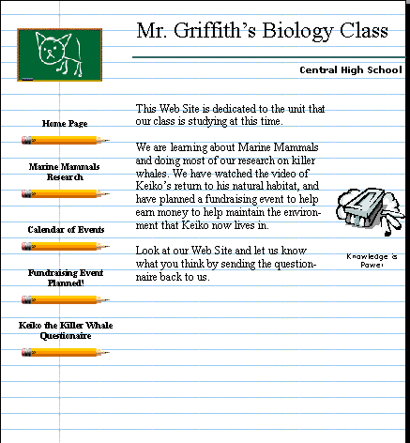
Personal Web sites are a great way to showcase student writing and to publicize school activities, sports and other extracurricular events. Publisher 2000's Web Site Wizard helps you build your Web site with several different types of pages. You can include a calendar, stories, a form for visitor feedback, or a links page.

To create a Web site
- On the File menu, click New.
- Click the Publications by Wizard tab.
- Click Web Sites and then click School Web Site.
- Click Start Wizard.
- Read the introduction and then click Next.
- In Color Scheme, click Mist and then click Next.
- On Additional Pages, click Story, click Calendar, click Event, and then click Next.
- Under form, click Response Form and then click Next.
- On the Navigation Bar, click Just a vertical bar and then click Next.
- On Background Sound, click No and then click Next.
- On Background Texture, click Yes and then click Next.
- On Personal Information, click Other Organization and then click Finish.
- Save the file.

Adding another page to your Web site
After you have created your Web site you may want to add another page such as a Directory of Related Links. Add it between the fourth and fifth pages.

To add pages
- On the Status Bar, click the Page 4 icon.
- On the Web Site Wizard in the left pane, click Insert Page.
- On the lower-left pane, click Insert Page. The Insert Page dialog box appears.
- On Available Page Types drop-down box, scroll down and click Related Links, and then click OK. Publisher 2000 inserts this new page after the page you've selected.

Modifying the text of your Web pages
With the aid of the Web Site Wizard, you've created the layout for your Web site, including hyperlinks, text frames with sample text, and graphics. Next, you'll want to make changes.

To replace text
- On the Status Bar, click the Page 1 icon.
- Click the Home Page Title text frame and type the title you want for your Web site.
- Click the other text frames and insert a text file or replace the text with text you've written for the Web site. On the following pages, continue to replace text with your new material.
- On the File menu, click Save to save the changes you made.

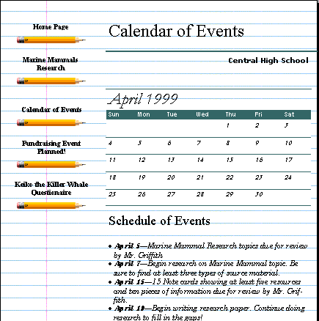
Customizing your calendar Web page
When schedule changes occur, you can quickly and easily update your Web calendar, with Publisher 2000. The current month shows on the calendar page, but you can add additional months’ dates on the lower part of the calendar page.

To customize the calendar page with the Calendar Creation Wizard
- On the Status Bar, click the Page 3 icon at the bottom of the Publisher window to go to the calendar page.
- Click anywhere on the calendar.
- Click the Wizard wand.
- Under Design, click Bars.
- Click Dates.
- Click Change Dates.
- Select a month from the Start Date field.
- Select a year using the arrows.
- In the Schedule of Events frames, click the first occurrence of the word date and type October 23.
- Click the text to the right of the date and type Keiko fundraiser.
- Add other dates and additional text to fill out the calendar.
- On the File menu, click Save to save the changes you made.

Updating your Events page
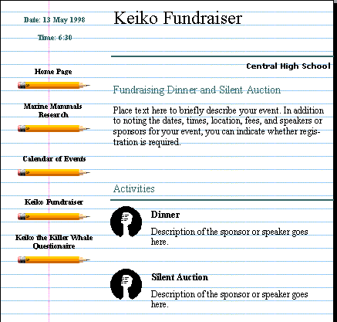
The Events page is the perfect place to let people know about upcoming fundraisers and other events your organization is involved in. Customize the Events page by adding upcoming events and revise it any time your organization's schedule changes.

To add speakers and topics
- On the Status Bar, click the Page 4 icon.
- Click the Seminar Event or Title text frame and type Keiko Fundraiser.
- Click the Business Name text frame and type your school name.
- Click the Seminar or Event Title text frame and type Keiko Fundraiser.
- Continue to replace the text on the page with text applicable to your event.
- On the File menu, click Save to save the changes you have made.

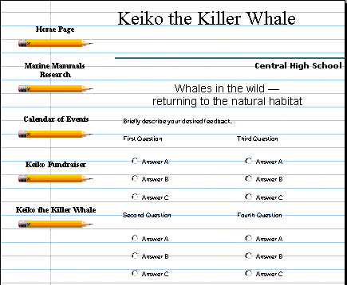
Adding a survey page to your Web site
A great way for students to practice primary research without leaving the classroom is through a survey conducted over a Web site. You'll find that you're much more likely to get responses to your survey when respondents can return the survey over the Web, rather than mail it back to you the traditional, more time consuming way. When your readers complete your survey, all they need to do is click Send and you've got the results. In the following procedure, you'll be adding a multiple-choice survey to page 5 of your Web site.

To insert a survey page
- On the Status Bar, click the Page 5 icon.
- Click the Form Page Title text frame and type Keiko the Killer Whale.
- Click the Briefly describe your desired feedback text frame and type We are looking at opinions about whales and Keiko. Please take a few minutes to answer the following questions.
- Click the First Question text frame and type your first question.
- Click the Answer text frames and type in the answers from which you want the respondents to choose.
- On the File menu, click Save to save the changes you made.
To learn more about how to collect and work with the survey information on your Web site, ask the Office Assistant about receiving form data.

Changing the look of your Web page
After you’re done entering text and replacing graphics on your Web site, you may decide you want to apply a new design to the entire Web site and change the look of the navigation bars. Returning to the Web Site Wizard, you can make those changes easily

To change the design and color scheme
- On the Status Bar, click the Page 1 icon.
- On the Web Site Wizard pane, click Design.
- Under Design, click Arcs.
- Under Web Site Wizard, click Color Scheme and then click Mountain.

Creating hyperlinks to other pages
The Web Site Wizard already created hyperlinks to help visitors navigate through your Web site. You can add additional hyperlinks to text and objects such as pictures in a collage. To add hyperlinks to part of an object, use the Hot Spot Tool. Use the following instructions to link a picture on page 1 to the survey on page 5.

To link to other pages within your Web site
- On the Status Bar, click the Page 1 icon.
- Click the picture on this page.
- On the Insert menu, click Hyperlink.
- In the Create a Hyperlink to field, click Another Page in Your Web Site.
- Click Specific Page and then click the down arrow until you get to the number 5.
- Click OK.

Linking your page to the rest of the Internet
Connecting to another Web site is as easy as creating a hyperlink to another page on your own site. For instance, you can link your Web page to the Discovery Channel home page so that people interested in the research you did on marine mammals can find additional information about sea life.

To link to other Web sites
- On the Status Bar, click to the Directory of Related Links page.
- On the Objects toolbar (vertical toolbar), click the Hot Spot Tool.
- On the first Web site name and address text frame, position the mouse pointer where you want the upper-left edge of the link to be and then drag the mouse diagonally down to the right to create the hot spot.
- In the Hyperlink dialog box, click A Web Site or File on the Internet.
- In the Internet address of the Web site or file drop-down box, type the address of the site to which you want to link.
-Or-
Click Favorites to browse through your Favorites folder to find a Web address.
- Click OK.
- Follow steps 1 through 6 to create additional links.
- On the File menu, click Save to save the changes you made.

Preview your Web site
Once you've created your Web site, you'll want to make sure it looks the way you planned. If you do not have a Web browser installed on your computer, ask the Office Assistant how to install one.
To view your Web site
- On the File menu, click Web Page Preview.
- Click Web Site to preview the pages in your Web site and then click OK. You should now be viewing the Web site with a browser.
- Click the clip art on page 1 to jump to page 5.
- Click the Calendar link on the left to jump to the Calendar.
- Click the Form link on the left to jump to the Survey.
- In your Web browser, click Back to return to the previous page.
- On the File menu, click Close to exit the browser.
- To exit Publisher, click Exit on the File menu.

Microsoft Publisher Tips and Tricks
Keyboard Shortcuts
Page layout programs like Publisher are, to a large degree, about formatting text into a legible and inviting configuration. And page layout pros save a lot of time by using keyboard shortcuts for their most often used actions. To that end, here are some keyboard shortcuts for some often used text formatting options:
Ctrl+B for bold text
Ctrl+U for underline
Ctrl+I for italic
Ctrl+= for superscript
Ctrl+Shift+= for subscript
Ctrl+Shift+K for small caps
Ctrl+Spacebar removes all style formats from the highlighted text
Ctrl+Shift+f accesses the font menu, arrow keys select, and enter changes the selected text to that font
Ctrl+Shift+P accesses the font size menu, arrow keys select size, and enter enables the change
Ctrl+Shift+> increases the font size by a half point
Ctrl+Shift+< decreases the font size by a half point
The Nudge Option
For a high degree of control over the positioning of objects on the page use the nudge option. Just select the object you need to move and use Alt+Arrowkey (up, down, right, left) and your object will move one pixel for each keystroke. Use Arrange-->Nudge to change the increment of movement.

Absolute Positioning
Even better, go to Format-->Size And Position and use numerical values to position and size objects. This is the absolute best way to make sure things will look right when you are going to press with a design. Trying to position objects by eye on your monitor can be deceiving because of the relatively large size of the pixels it uses to display objects. Do the math and use this method when you want your design elements to be positioned exactly.

Grouping Elements
After you have a section of your layout positioned very precisely it might be a good idea to select all the items (hold down the shift key and click on each one) and then group them together using Arrange-->Group Objects or (Ctrl+Shift+G). This will lock them together in their relative positions. This is especially useful if you will need to duplicate this configuration somewhere else in your layout; copy and paste the group to another page and you will have perfect consistency throughout your layout.

Automatic Wrapping
You don't have to press Enter (return) at the end of each line, just at the end of a paragraph. Simply type away and let Publisher wrap the text automatically. This may save you lots of time, especially if you decide to change your type size later--you won't have to go back and take out all those extra Enter commands. If you need to make a line end shorter than a full line, use Shift-Enter, called a soft return.

One Space, or Two?
Instead of putting two spaces after each sentence, just put one. This is a standard in the industry.

Putting Things in the Background
Publisher uses foreground and background layers. Your work will go on the foreground by default unless you set it to be in the background. You might want to use images or text in the background. Here's how to do it: choose View-->Go To Background. This will take you to the background of the publication.

Spacing and Alignment
Check the alignment of frames, text, pictures and captions. It should be consistent throughout your publication. Also check spacing between headings, paragraphs, and pictures. The spacing should be consistent throughout your publication.

Spelling and Punctuation
Don't forget to check your spelling, punctuation and grammar. Run the spell checker; select Tools-->Spelling-->Check Spelling. Another good one is to check the accuracy of hyphenation: select Tools-->Language-->Hyphenation. It's a good idea to have someone else look at it too. They may see something you've been looking at and missing.

